* Film title contains the word *Uptown* in any position

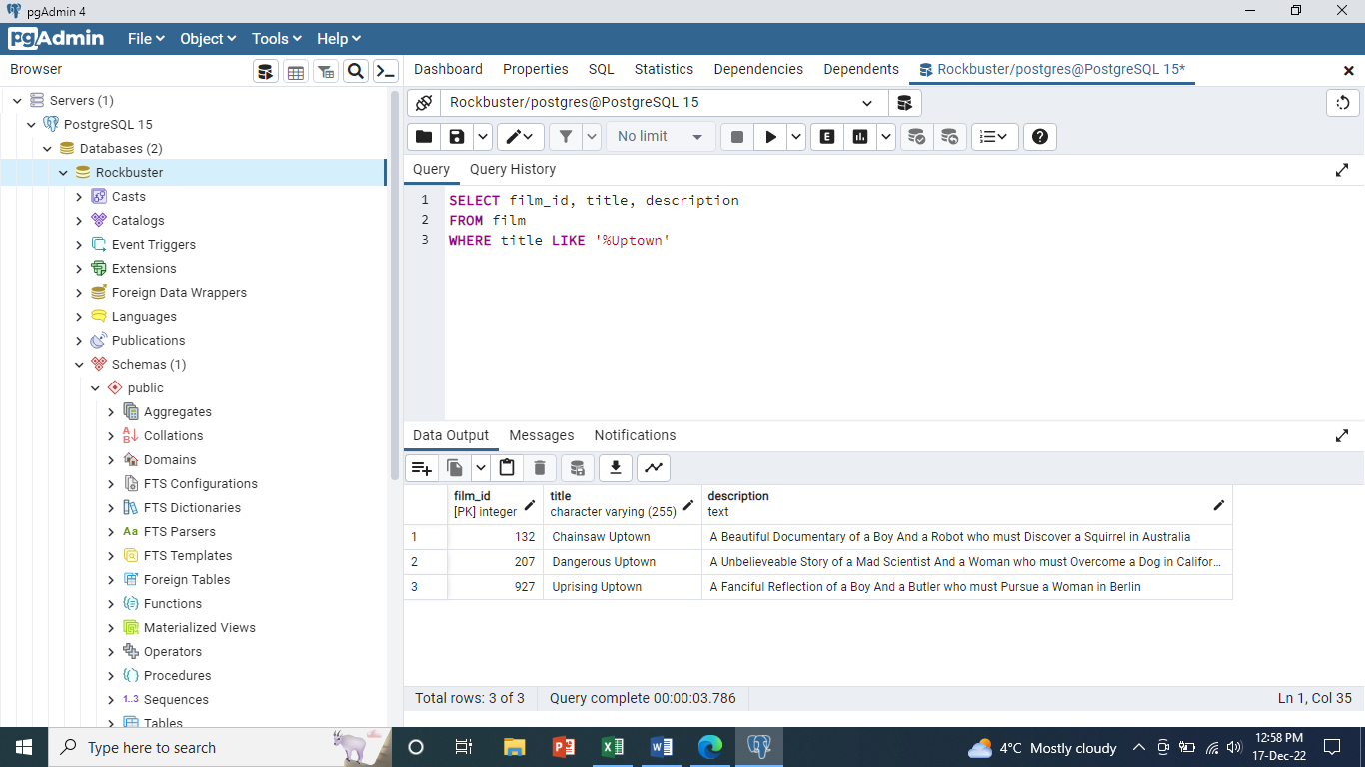

* Film length is more than 120 minutes and rental rate is more than 2.99

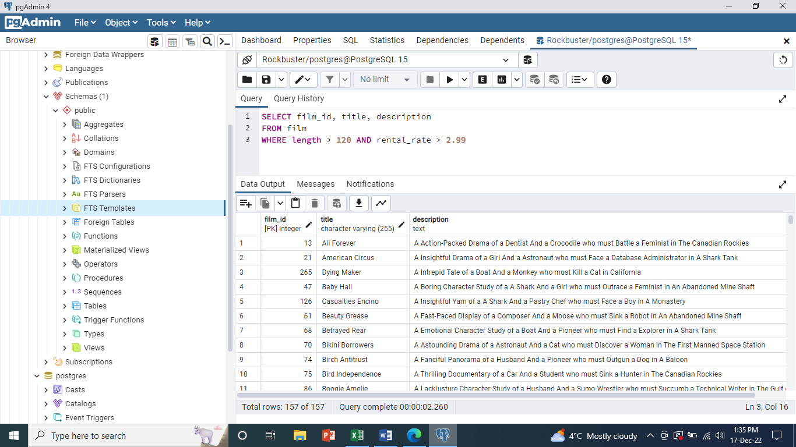

* Film replacement cost is less than 14.99

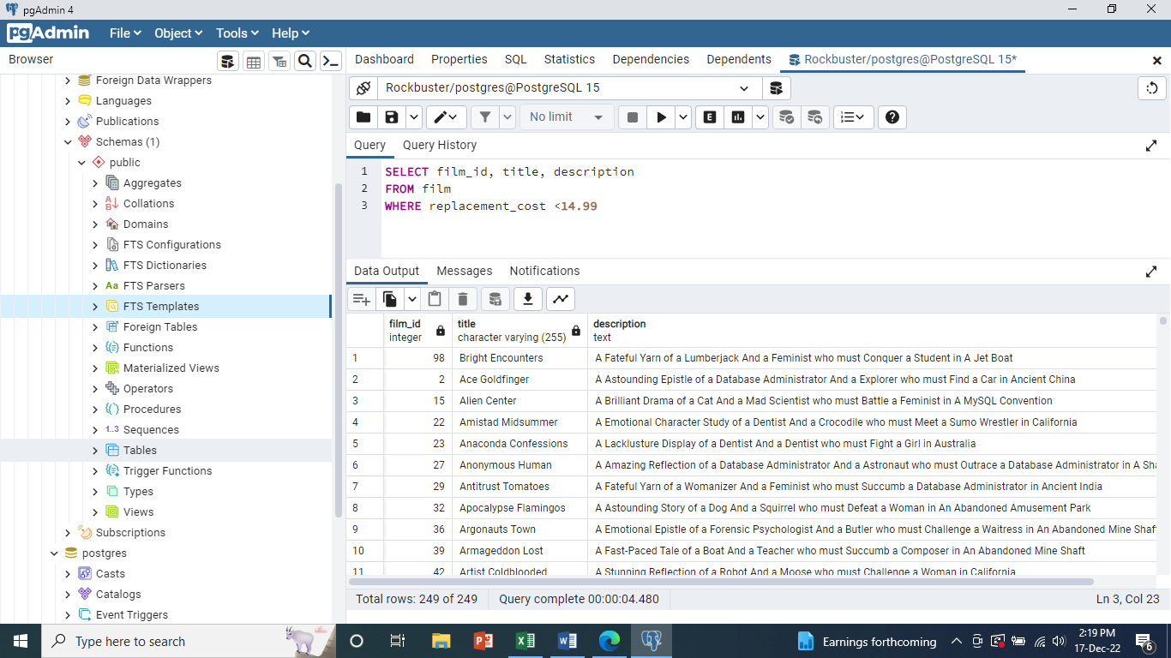

* Film rating is either PG or G

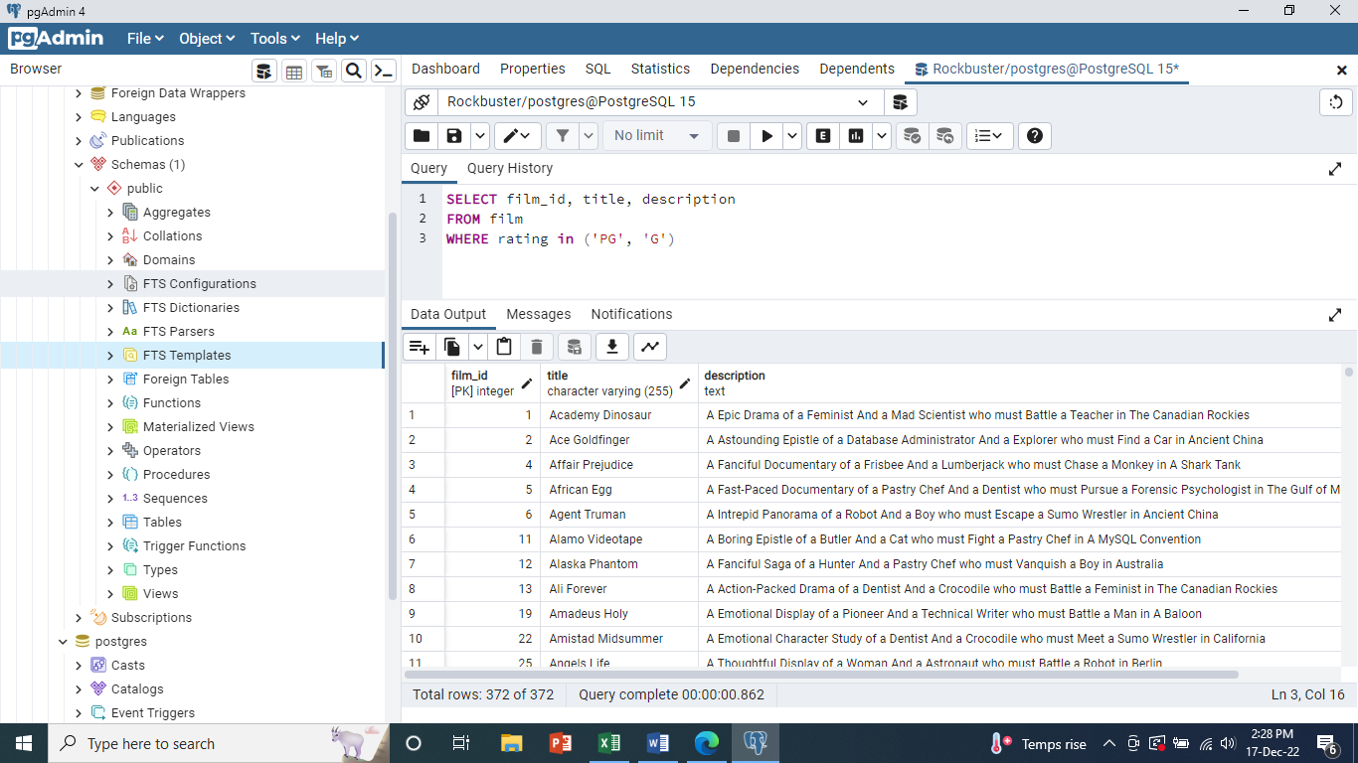

The inventory team has asked for the following information about this list:

Count of the movies

Average rental rate

Maximum rental duration and minimum rental duration

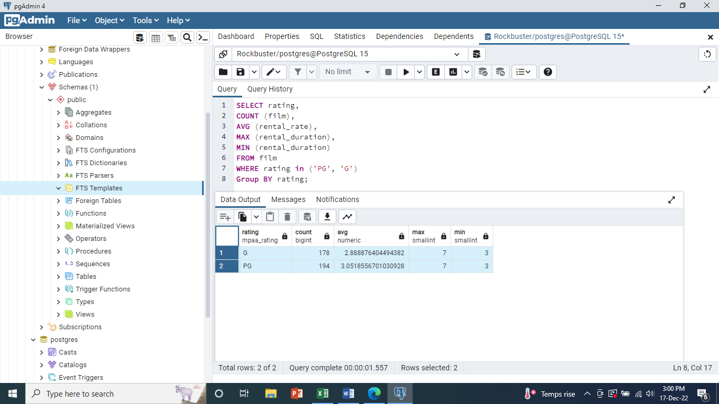

To make the output easier for your coworkers to understand, give your aggregate columns the following aliases: “count of movies,” “average movie rental rate,” “maximum rental duration”, and “minimum rental duration”. Run the query and transfer the result into your Excel file on a new sheet as well as the code you used to get there

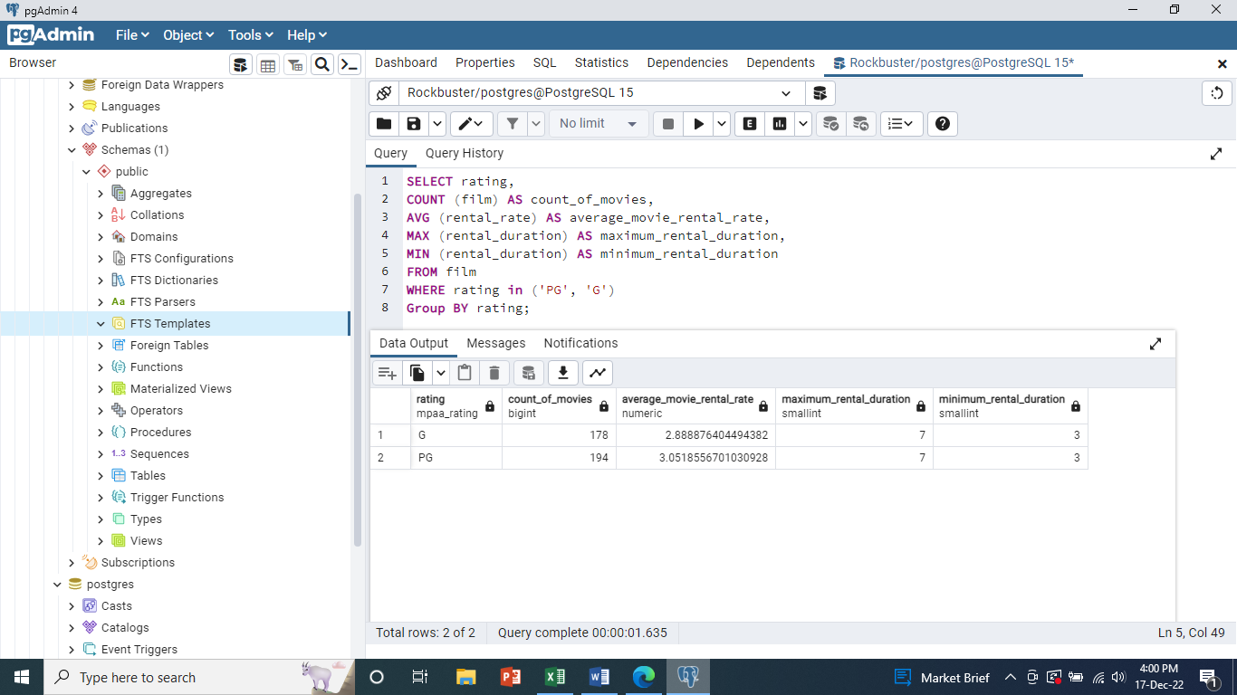

The customer team would like to see the fields you calculated in step 3 grouped by rating. The totals in your results table should look the same as in step 3 but broken down by the rating column. Copy-paste your query and its output in your answers on a new sheet

